**Multiprogramming vs Multitasking**

* Both are the same “Multiple programs or tasks are executed simultaneously by the OS but not at the same time”. The difference is Multiprogramming word is concerned with Linux/Unix/mac OS and Multitasking term is concerned with Windows operating system.

**Types of Multiprogramming**

* Single user vs multiple user (multiple user multiprogramming operating system is involved in 70’s in Linux operating system)
* Preemptive vs non-preemptive (today most operating system is preemptive, windows 3.0 and windows 3.1 are non-preemptive operating system)

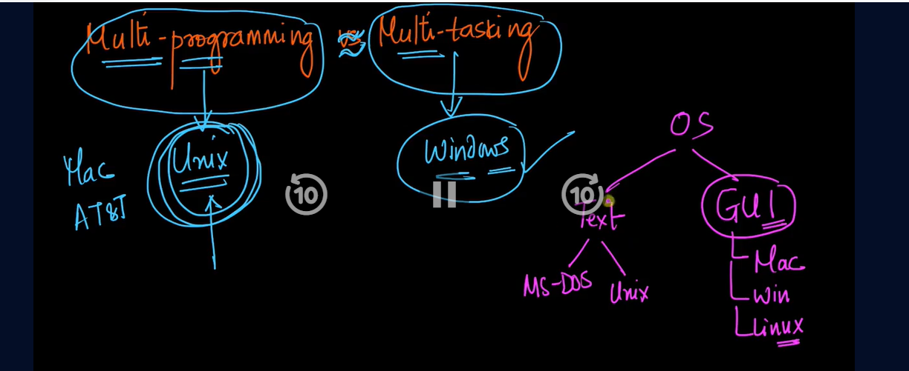

**Modes of Execution on a CPU**

1. User mode

* Preemption is possible

1. Kernel mode

* Preemption is not possible because the core functionality of operating system is run by the kernel
* If there is n fork () call in program then total 2^n processes are generated including to the original process.
* To the parent process, fork () returns the process id of its child process.
* And for the child process its id is 0

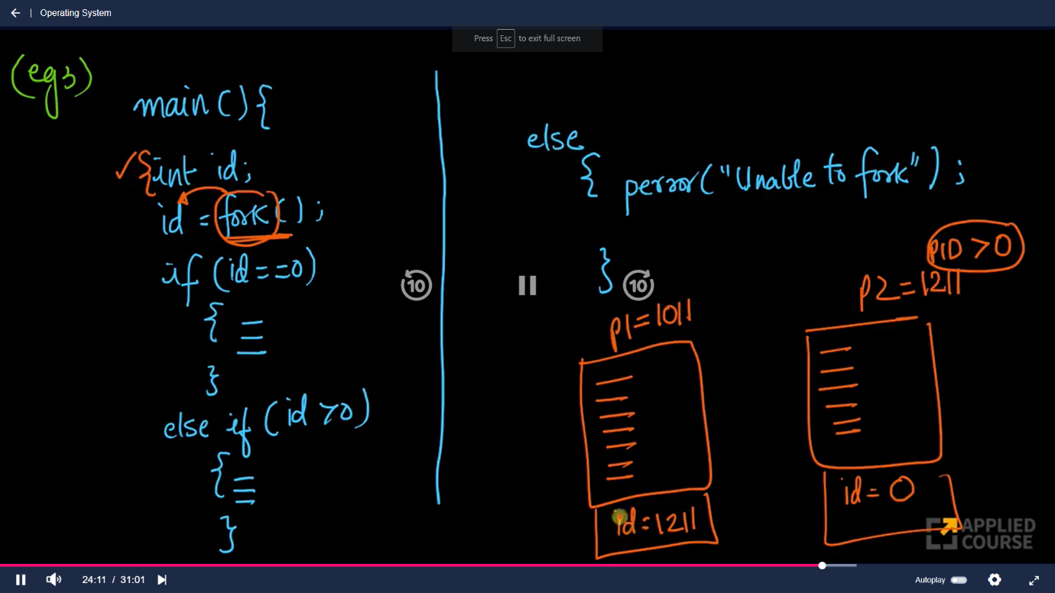

Fork returns integer values

* If it returns 0 it means it is child process.
* If it returns positive value, it means it its parent process
* If it returns negative value then “You have some error occurred”

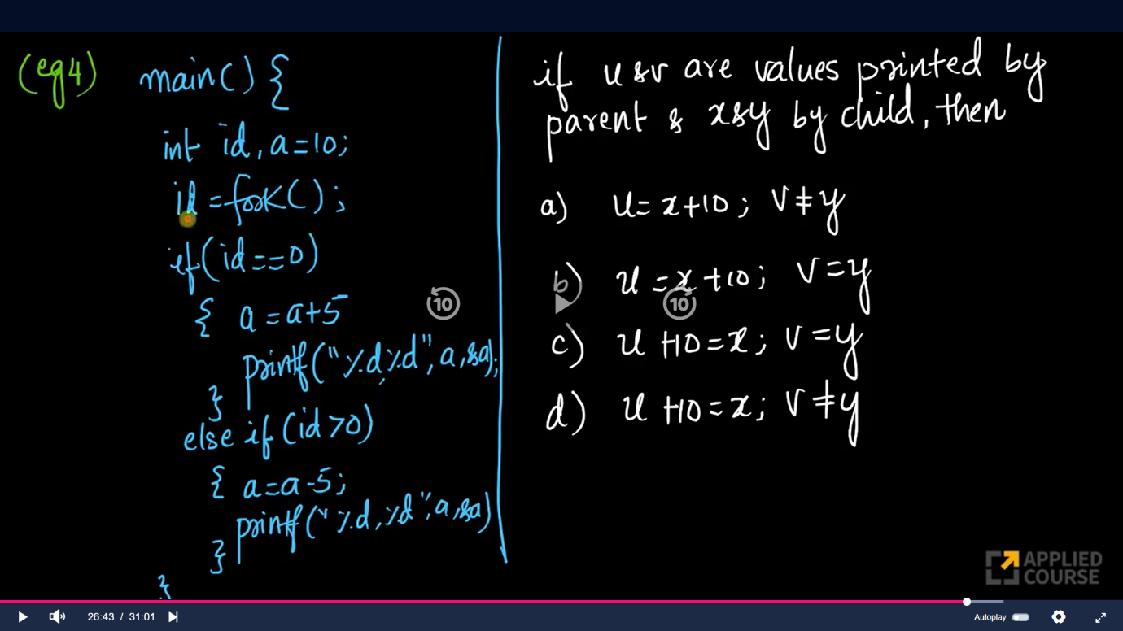

Output: option d

Problem 1

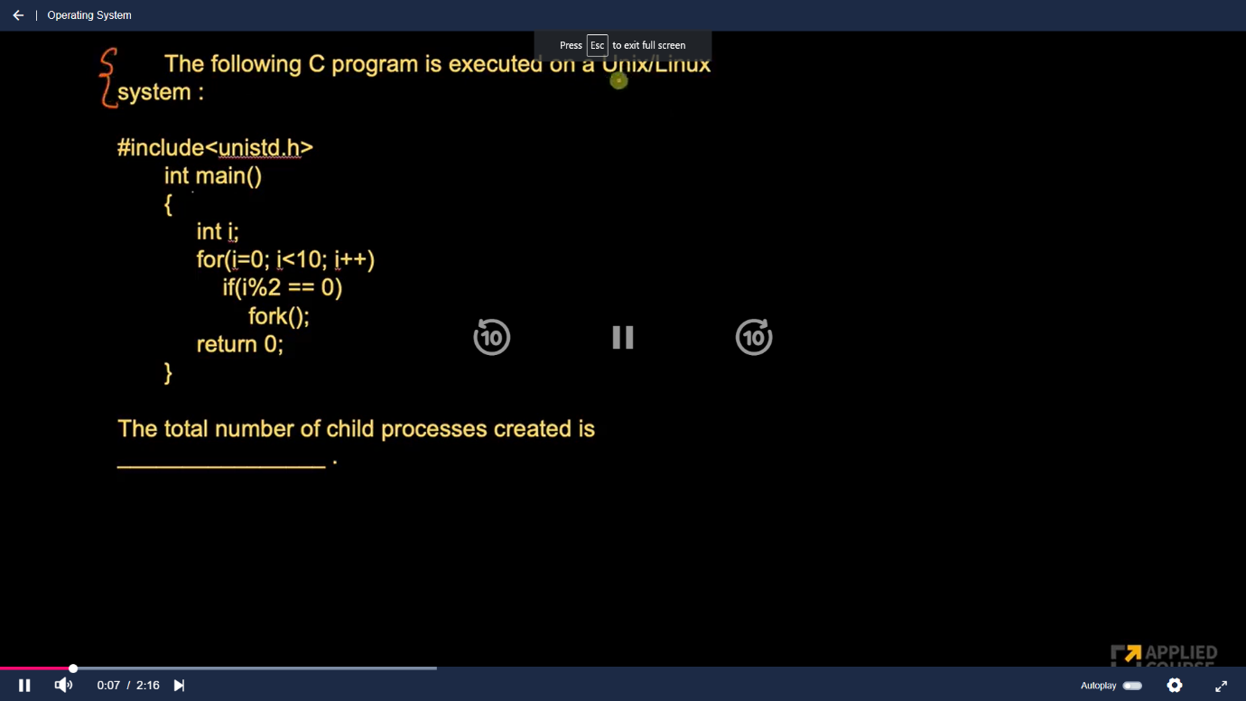

Output: 31

**Attributes of process**

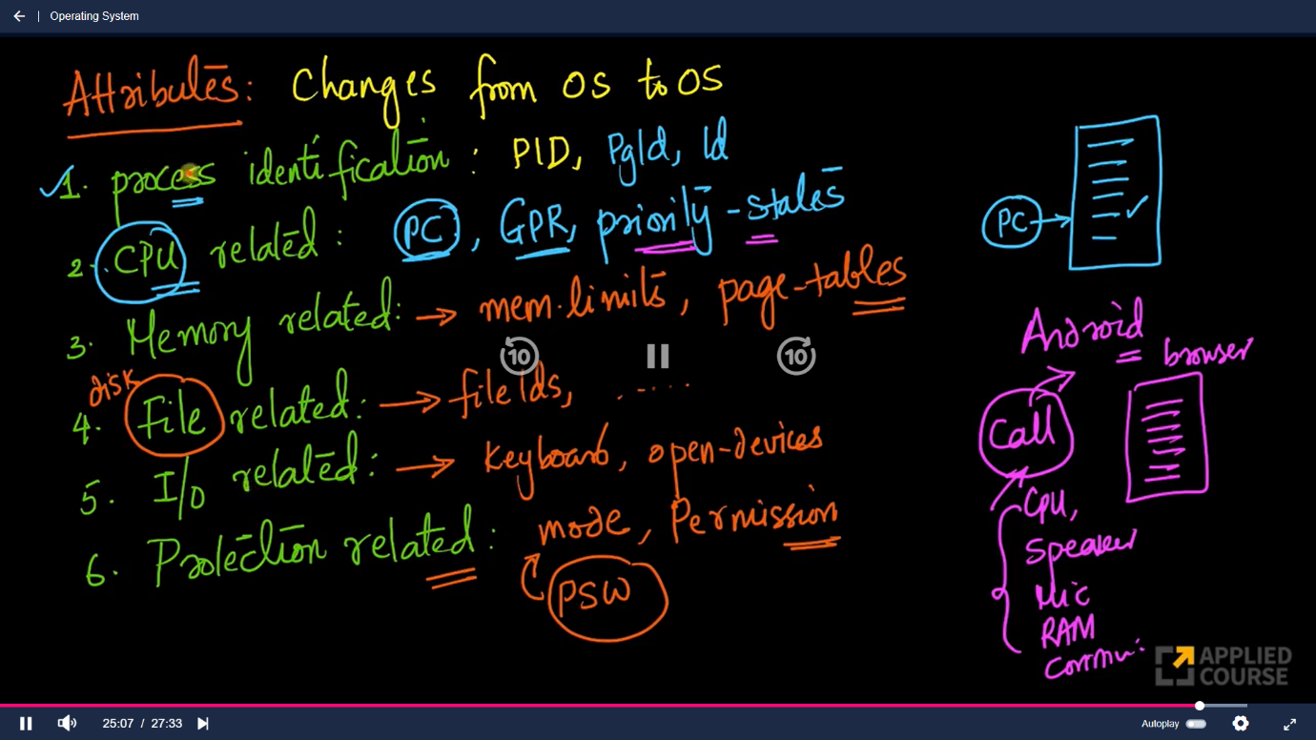

* All these attributes of process are stored in PCB (Process control Box)
* Every process has its own PCB
* PCB is data structures which stores all the attributes corresponds to the process
* PCB sometimes also known as context or environment of the process

**Process States**

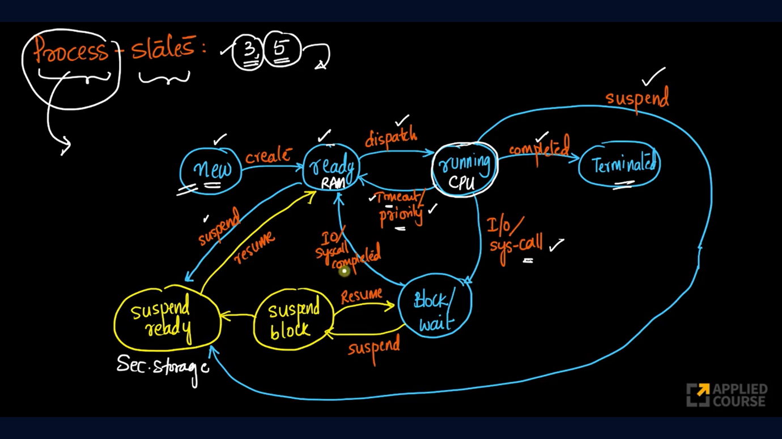

**New:**

* Process created and ready to be executed
* Create operation takes all the instruction of the program, assign all the static variables, assign space for recursion calls which is runtime stack, create space for dynamic memory allocation, places the process into RAM then the process is in **ready state**.

**Ready state:**

* Process in RAM or Main memory.
* Dispatcher is module in OS, which takes the process from ready queue, and assign it to the CPU (which means process is moved to running state.).
* If the main memory or RAM is out of space then the process might have to be suspended, this will take out process from the main memory to swap space of secondary storage and process is moved from ready state to suspended ready state.

**Running State**

There are four possibilities in running state:

1. If the process completes its execution, then process moved to the **terminated state.**
2. When the timeout completes or any other high priority process comes then the current process execution is stopped and process moved to the **ready state.**
3. If the current process has encounter some I/O related operations or any system calls then the process has to release the CPU and it’s moved to the **block/wait** state.
4. This the worst-case scenario happened which is when the process is running in CPU (or process is in running state) and there is some high priority process is come and RAM or main memory is full then high priority process directly goes to running state, so in this case current process which is being executed by CPU is moved to the *suspended ready state*, and high priority process gets CPU and moved to **running state**

**Block/ wait state**

* When the process is in block/wait state then it is waiting for some IO operations or some system calls to completes, if the IO operations or system calls are completed then process moved to the **ready state**
* The process is blocked for some IO operations or system calls to happened, and if the IO operations are not completed and the RAM goes out of the space then the process is moved from block state to suspend block state

**Terminate**

* When the process is in terminate state then it releases all the resources which are allocated to it.

**Suspend block**

* Process is in secondary storage
* When the process is waiting for some IO operations to be happened and RAM or main memory goes out of space then process is moved from block state to suspend block state.
* If the process in suspend block state and RAM gets space for the process then it resumes back to the block state from suspend block state, completes IO operations and moved to ready state.
* If process is in suspend block state and it completes its IO operation (still not get memory in RAM) then it is moved to the suspend ready state.

**Suspend ready**

* When the process is in suspend ready state then it is residing in secondary storage.
* When the RAM is freed up, process moved to the ready state from the suspend ready state

**Scheduling Queues**

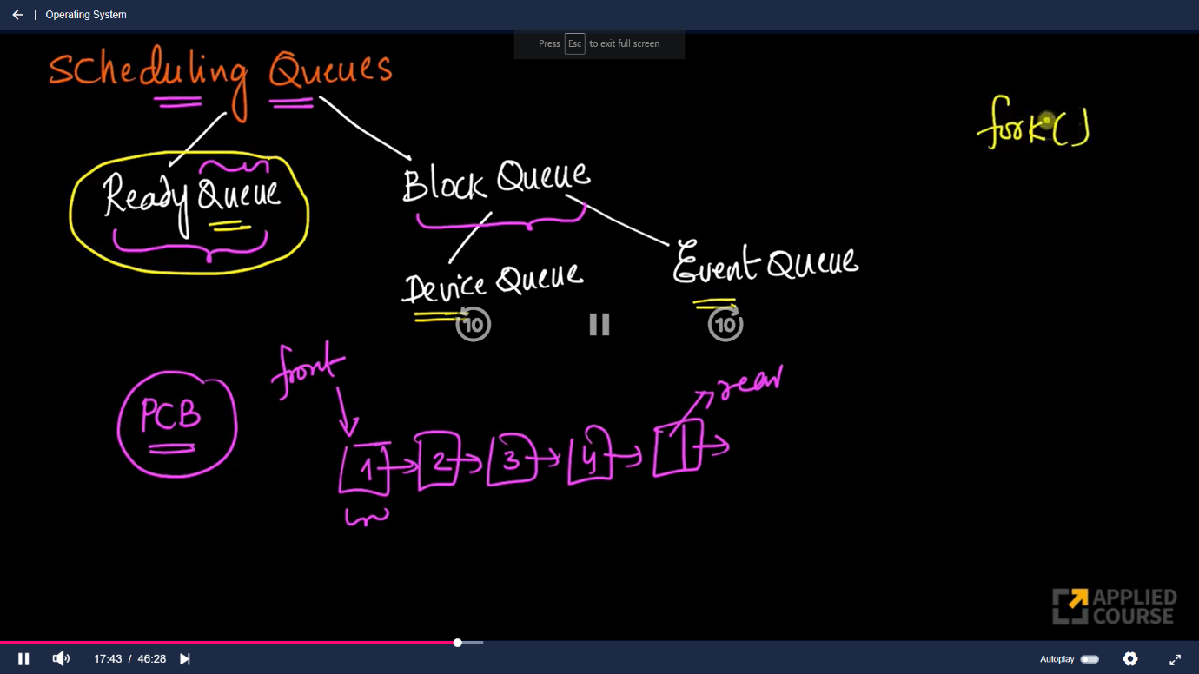

* A process can be uniquely identified by its PCB
* Device queue and event queue are stored in RAM.

**Ready Queue**

* Each cell in queue is PCB corresponds to one process.

**Device Queue**

* Every device has its own queue for example keyboard has its own device queue, printer has its own devices queue, and each queue of the device contains PCB of the process

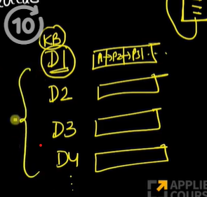

* Ex. Suppose D1 is device queue for keyboard and there are multiple processes which is waiting for keyboard then all these processes are waiting in keyboard’s device queue.

**Event Queue**

* Each event has its own queue.
* In case of fork call, parent process is waiting for an its child process to complete its execution. so, in this case parent process is wait for an event (Complete execution of child process) to be completed

**Suspend Queue**

* All processes which are in suspend state, but there is 2 suspend state so that there are 2 suspend queues.
* Suspend queues are stored in secondary storage.

**Job Queue / Input Queue**

* Consist of all the programs which are waiting to be loaded into memory/RAM into a process.
* Program is new state.

**Process state Queuing Diagram**

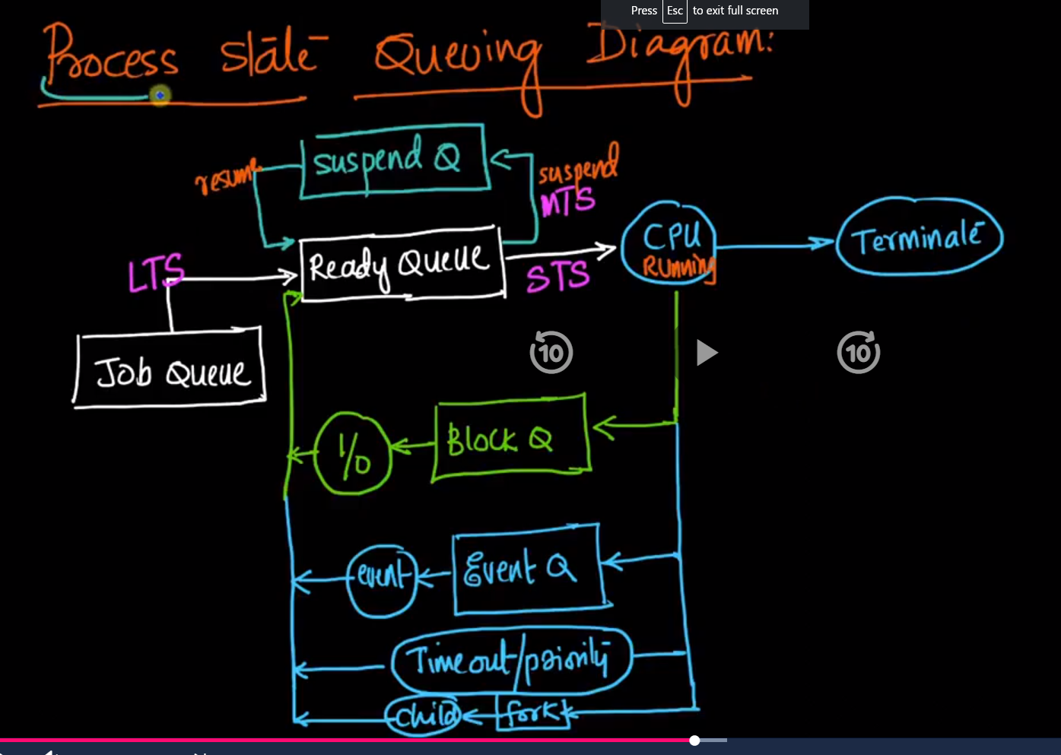

**Job Queue**

* LTS is known as long term Scheduler because moving the program from the job queue to the ready queue, so the process is stayed in memory for a very long time.
* LTS (Long term Scheduler) is picked up the one of the programs from the job queue and placed it into ready queue based on some criteria.

**Ready Queue**

* STS (Short term Scheduler) or CPU scheduler: it is known as STS because the time each process gets in CPU is quite small.
* STS decides which of the process from the ready queue is moved to the running states or assign to the CPU for execution.
* Ones the STS picks which process is given to the CPU for Execution, there is dispatcher which actually assign / allocate a process to the CPU

**Suspend Queue**

* MTS (Midterm scheduler): is known as midterm because process stays in suspend state for a mid-time
* Job of MTS is when the RAM/memory is full then move the process from ready queue to the suspend queue.
* When the process is in ready queue and RAM/memory is full then it is moved to the suspend ready queue.
* When the process is in block queue and RAM/memory is full then it is moved to the suspend block queue.

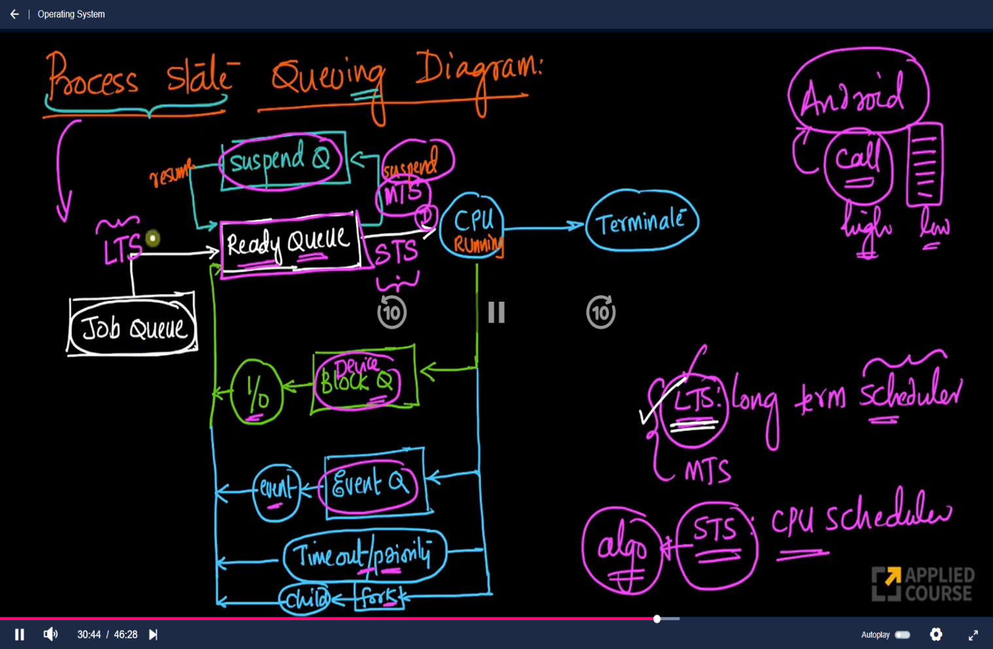

**Job Bound and CPU bound processes**

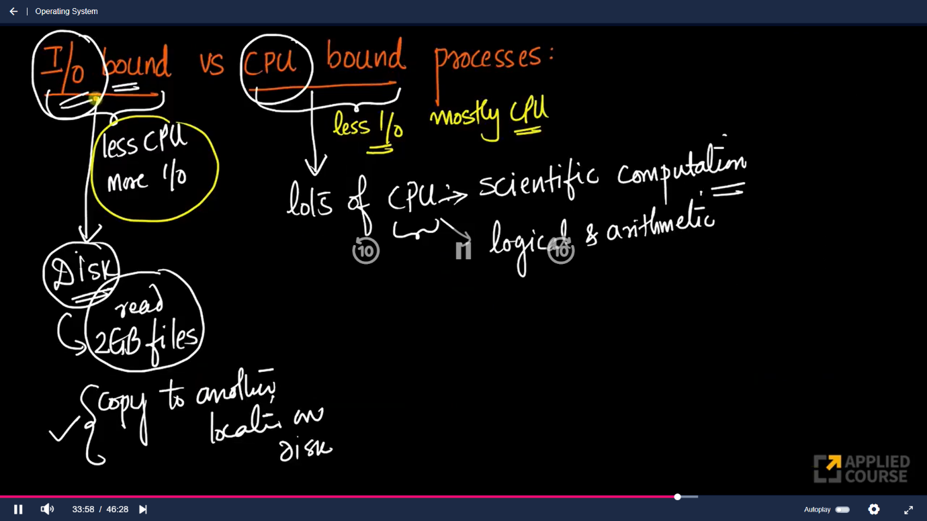

**Dispatcher**

* Dispatcher gives control of CPU to a process selected by STS.
* When the process execution is completed then the PCB of that process is completed destroyed by the dispatcher. Now CPU is become idle so that dispatcher is waits or inform the STS to picks the new process from the ready queue, after that dispatcher check the PCB of the process and move all the CPU related attributes of the process from its PCB to CPU’s register and give control to the control unit of CPU to start execution.
* When the process is running in CPU and it’s needed some IO Operation the it has to moved to the Block queue, but before that dispatcher saves the current state of CPU registers into process’s PCB, store this PCM into main memory, and after doing so dispatcher moved this process’s PCB to corresponding blocked queue. Now again CPU is become idle so that dispatcher is waits or inform the STS to picks the new process from the ready queue, after that dispatcher loads the new process, this is known as **Context Switching.**
* **Dispatcher perform the context switching.**
* Also, in case of preemption or processes timed out the dispatcher saves the current CPU registers state into PCB, stores PCB into main memory, and loads the high priority process or next process in ready queue.

**Question**

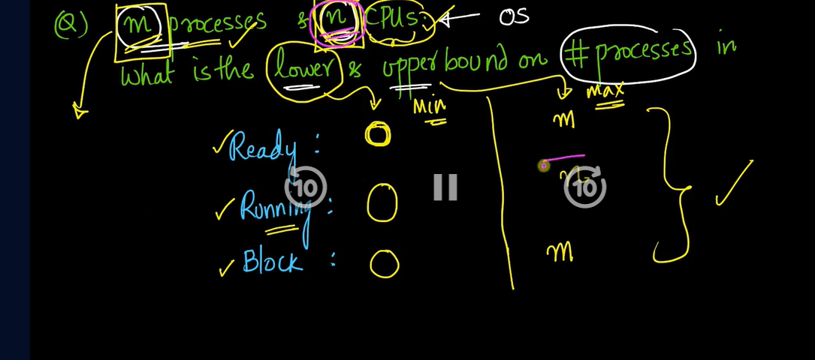

**Ready queue** has **minimum** **0** processes because if RAM size is too small and process can’t fit into it then all the processes are moved to the suspended state

**Ready queue** has **maximum m** processes because if RAM size is too large and all the processes are getting space in main memory then at max m processes are in ready queue.

**Running state** has **minimum 0** process because if all the processes are IO bound then all are in Blocked queue.

**Running state** has **maximum n** process because there is n CPUs available and if one process is running in one CPU then at max n processes are in running state

**Block queue** has **minimum 0** process because if all the processes are CPU bound then there is no process in blocked queue.

**Block queue** has **maximum m** process because if all the processes are IO bound then all the processes are in block queue

**CPU scheduler/ STS Scheduler**

Goal: maximize CPU Utilization

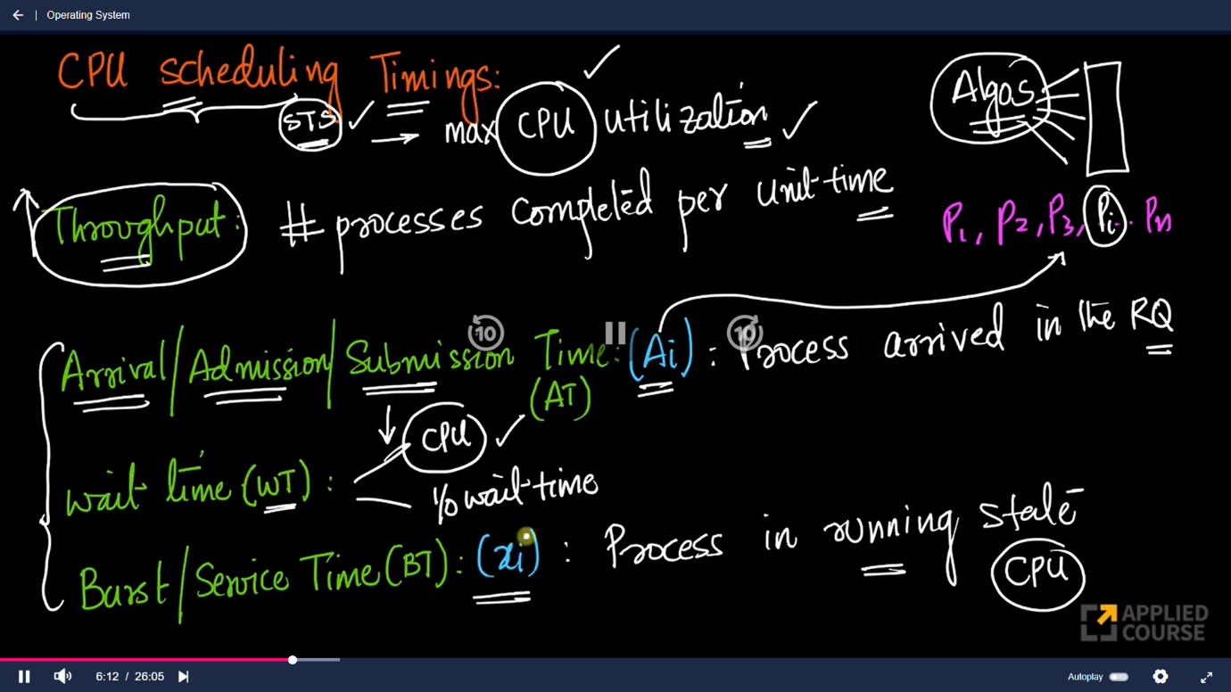

**Throughput:**

* No of processes are completed in unit of time
* Need high throughput

**Arrival time/ admission time / Submission time:**

* Time at which the process arrived in ready queue.

**Wait time**

* **CPU wait time**: the time process waits in ready queue without being assign to CPU
* STS is mainly concerned about CPU wait time because it cannot control IO wait time
* STS is focused on reducing the CPU wait time
* **IO wait time**: The time process is waiting for IO operation in blocked queue/device queue/event queue.

**Burst Time/ service time/ execution time**

* STS is focused on increasing the burst time
* The time process is in running state

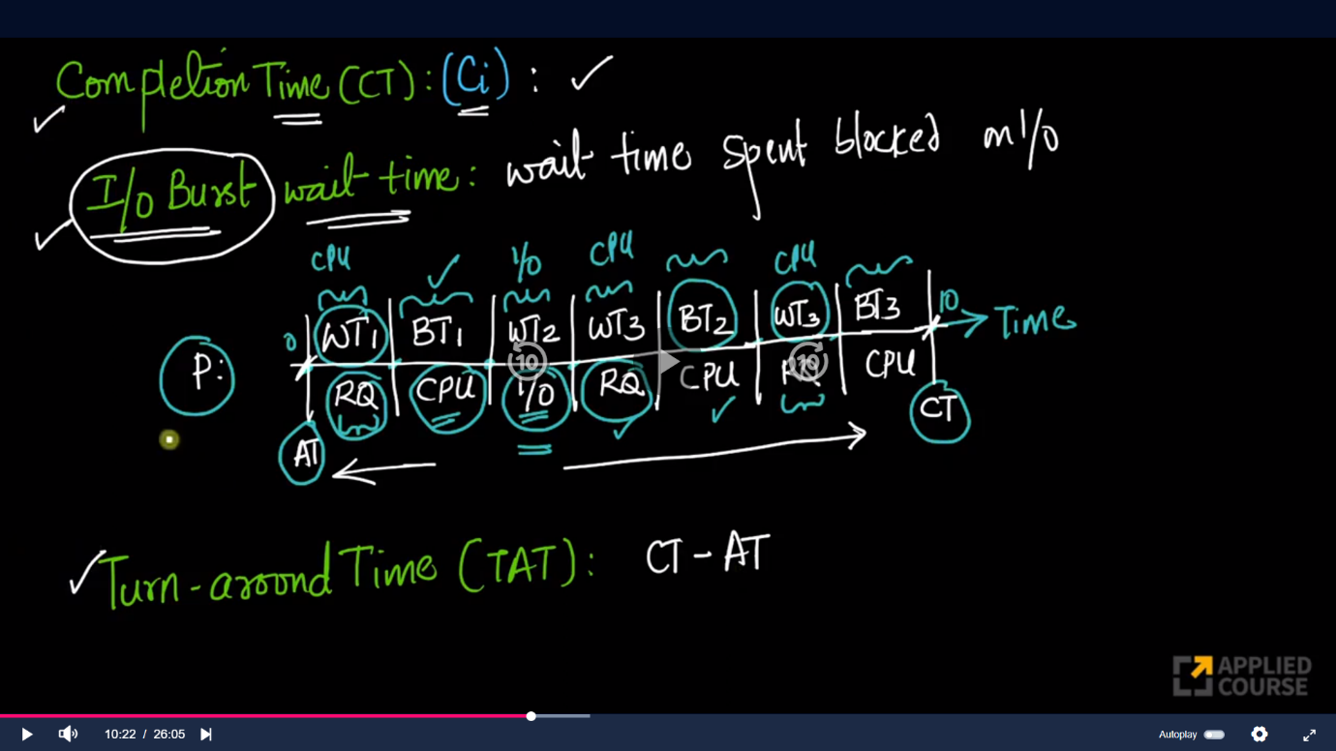

**Completion time:** process completes its execution

**Turnaround time (TAT):**

* Want to minimize TAT
* time difference between completion time and arrival time of the process
* CT – AT

**Response time**

* The difference between the arrival time and the time at which the process first gets the CPU is called Response Time.
* The first time when the CPU assigned to the process in ready queue
* Want to minimize response time.

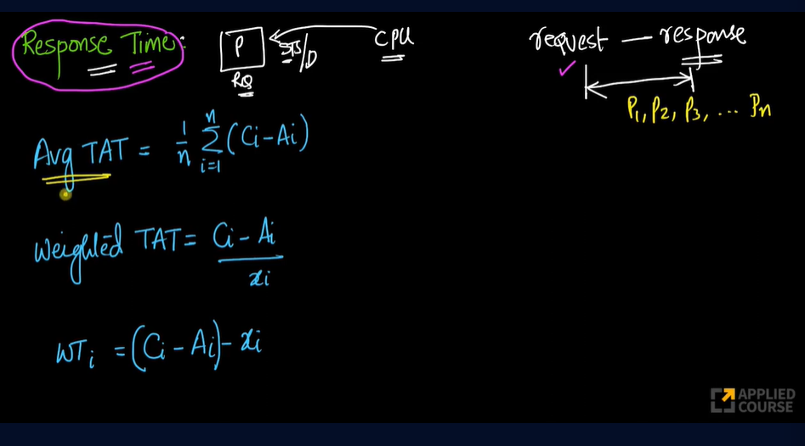

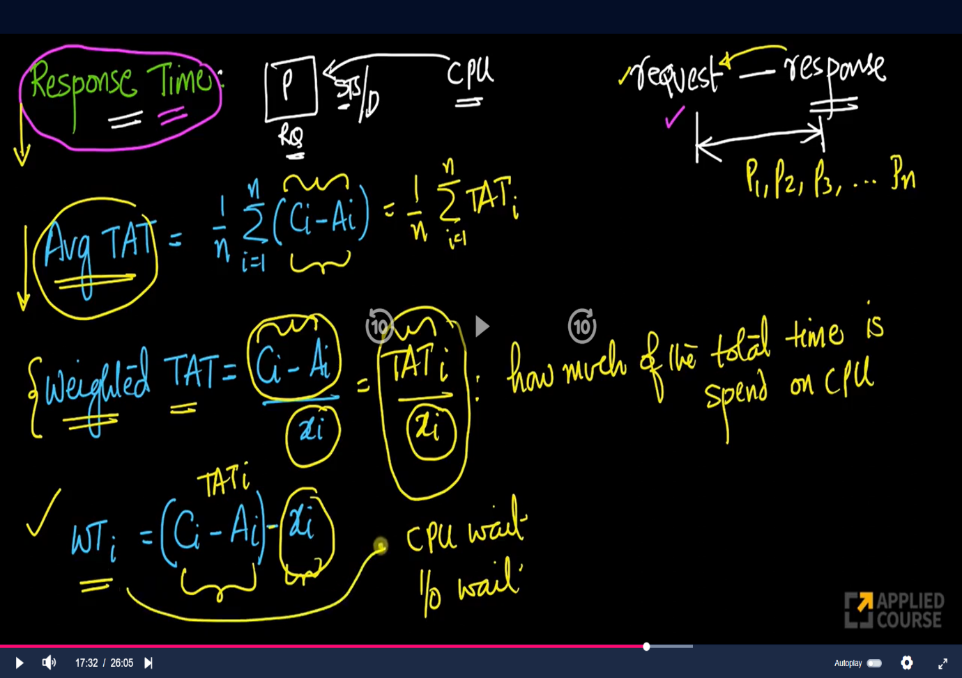

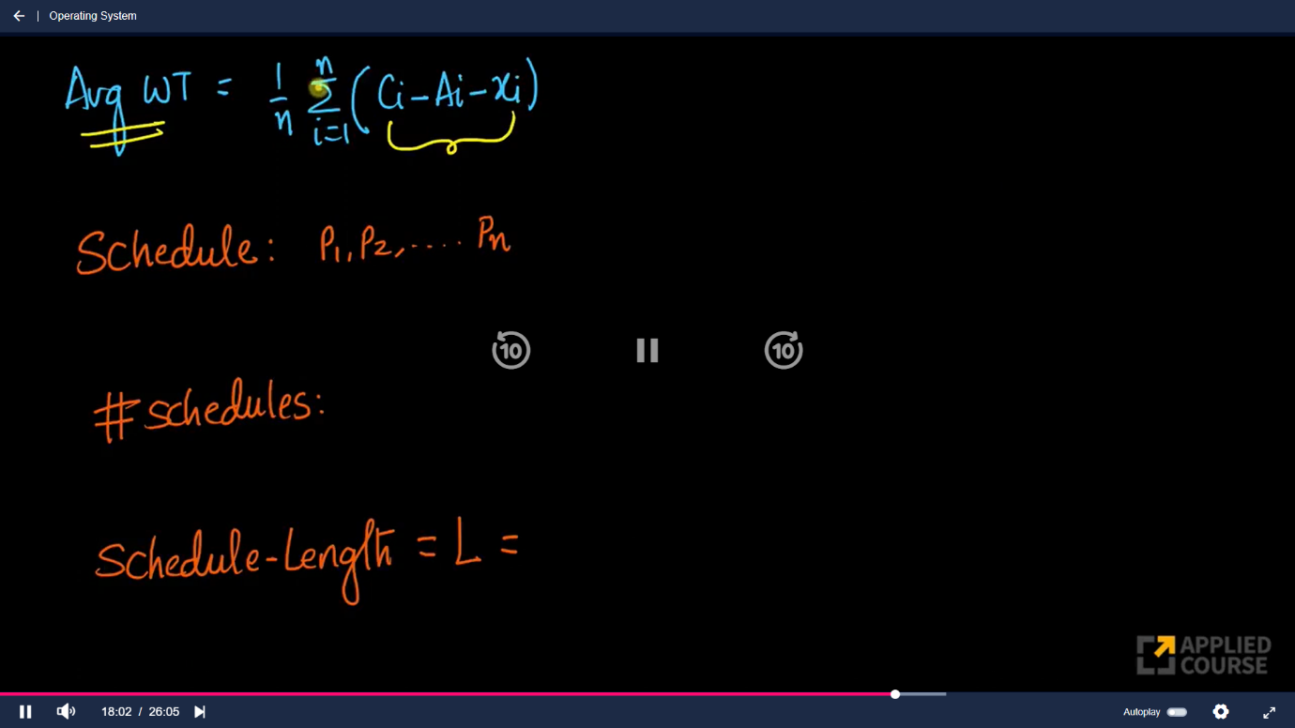

**Schedule length: Total time to complete all the processes in given schedule**

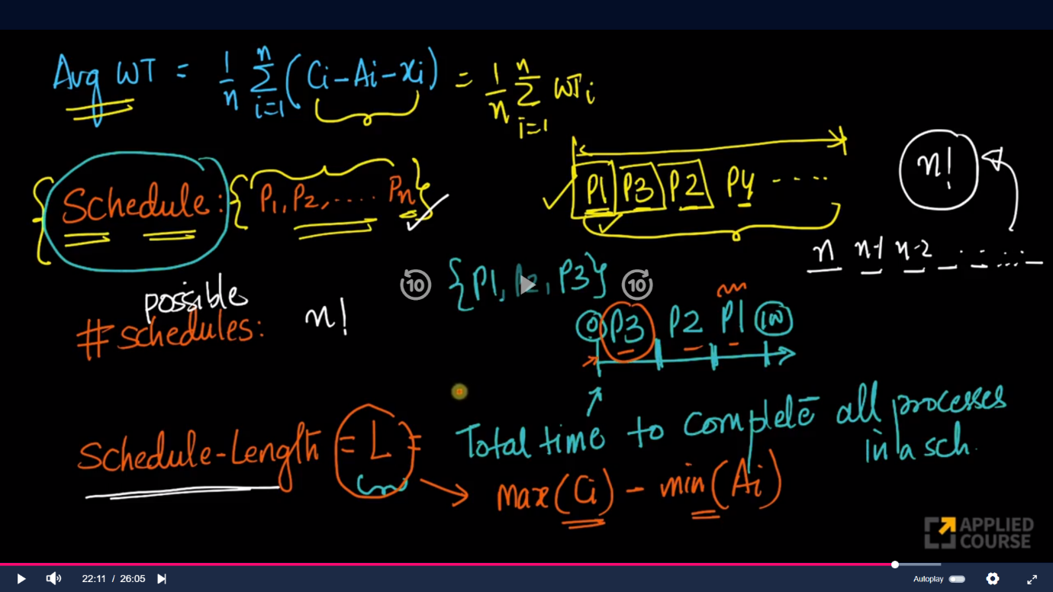

* From this throughput can be defined as below
* If the total no of processes in schedule are n and
* Schedule length time is L second then
* **Throughput = n/L**

**Deadline (Di):**

* the time stamp before which the process should completes
* If the process’s completion time is greater then its deadline time then it is known as **deadline overrun**, it means process’s takes more time than its given deadline time.
* If the process’s completion time is less than its deadline time then it is known as **deadline underrun,** process completes its execution before its deadline time.

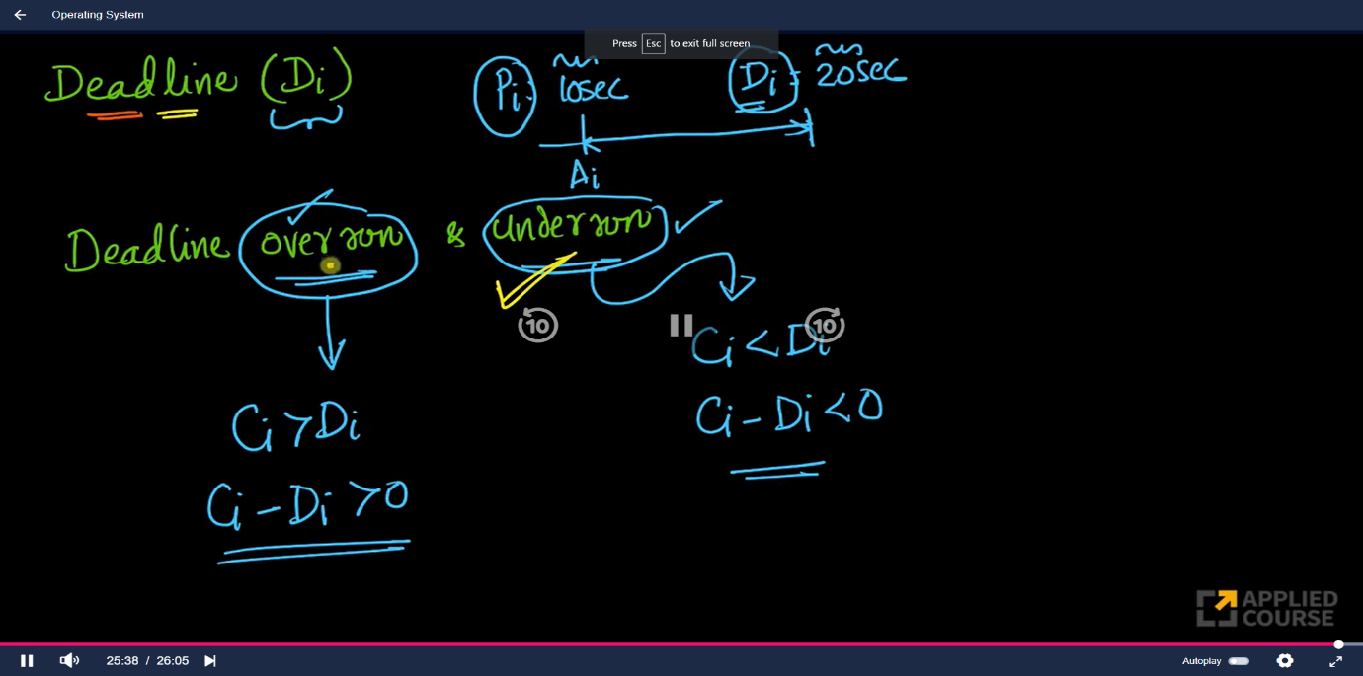

**Scheduling Algorithm**

1. **FCFS (First Come First Serve):**
   1. Assumption:
      1. There is no input / output
      2. Context switching time is negligible
   2. Non preemptive
   3. No starvation
   4. Criteria: Arrival time
      1. whichever process has less arrival time will be executed first

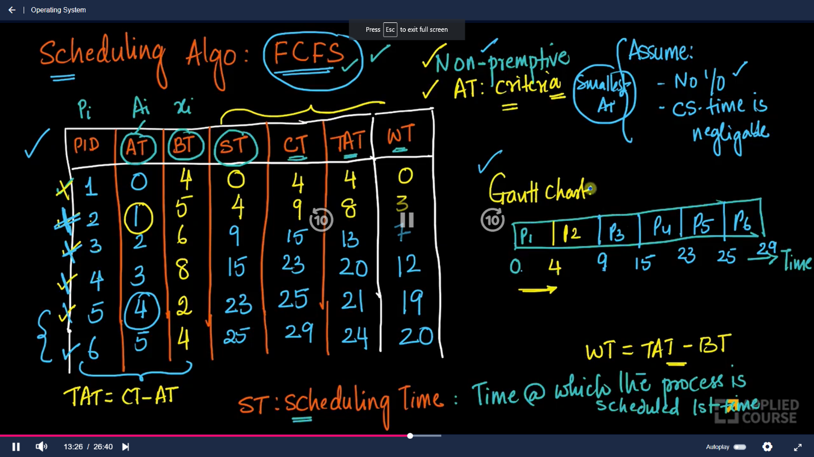

Example

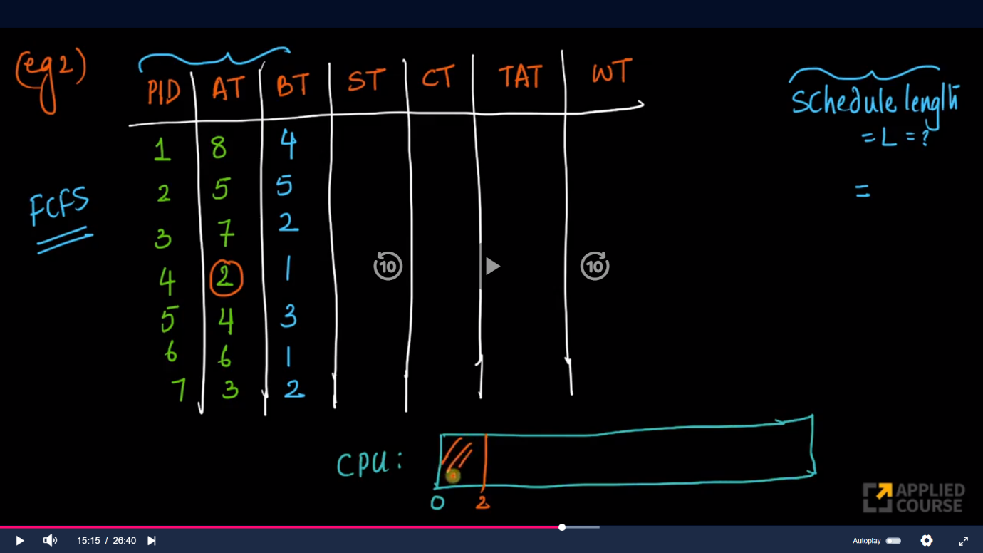

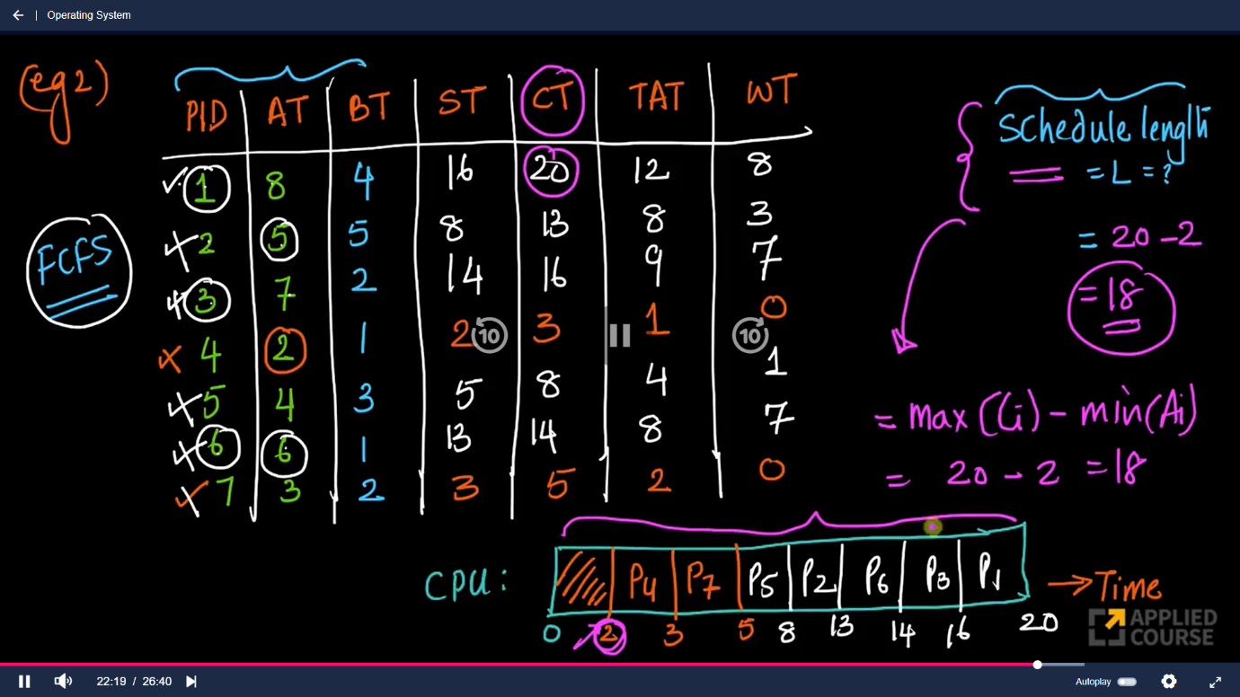

Ques 2

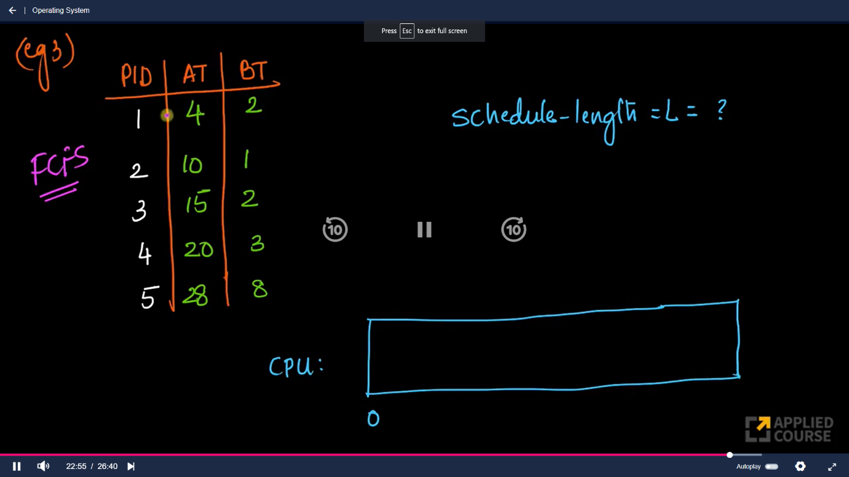

|  |
| --- |
|  |

1. **Shortest Job First**
   1. Non -preemptive
   2. Criteria: small burst time take first
   3. Increase throughput
   4. Starvation occurs for processes with high burst time.
   5. Starvation means process is waiting in ready queue for long period of time
   6. Advantage of SJF is throughput is increase and Average wait time and average Arival time are decreses

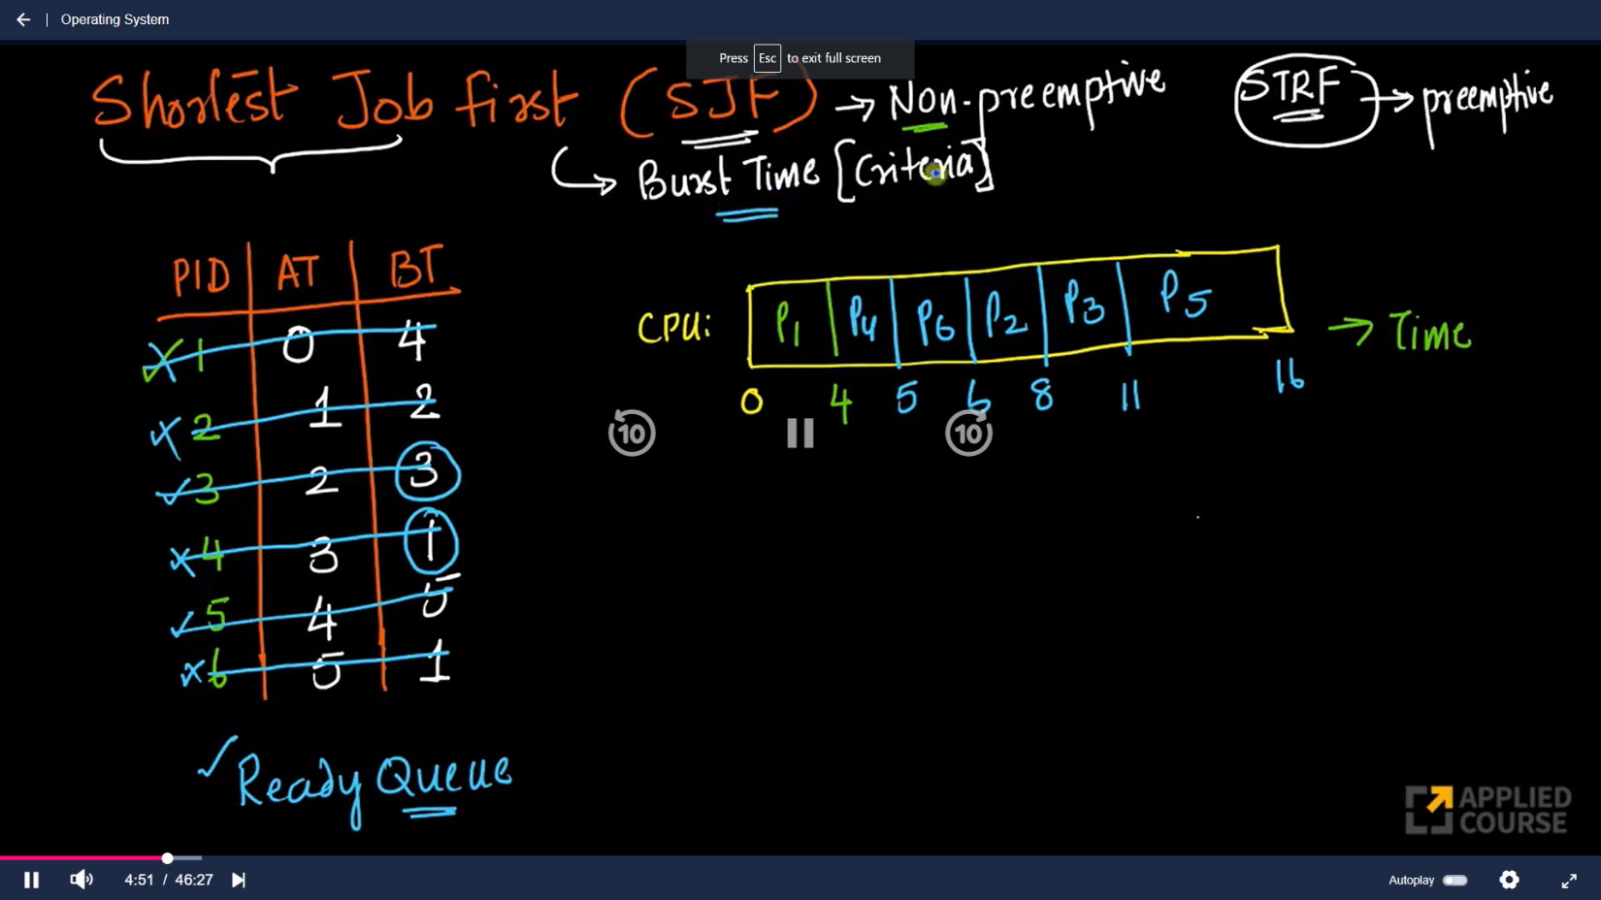

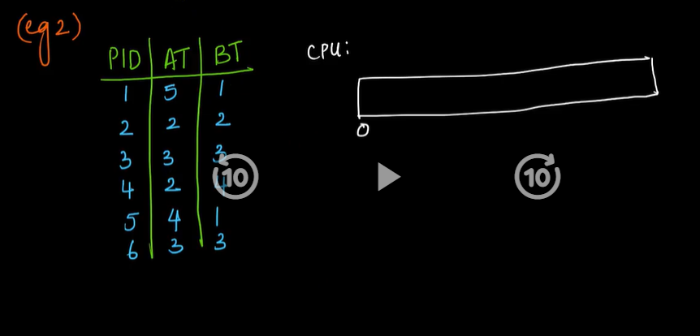

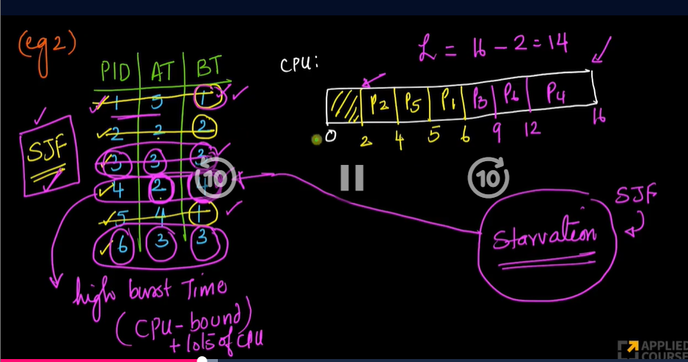

1. **Shortest remaining time first**
   1. Preemptive
   2. Starvation occurs.

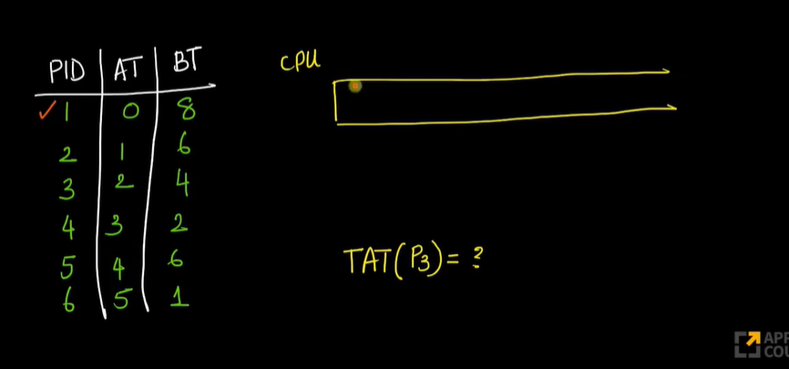

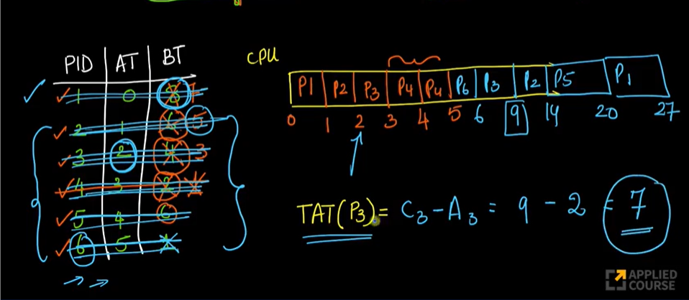

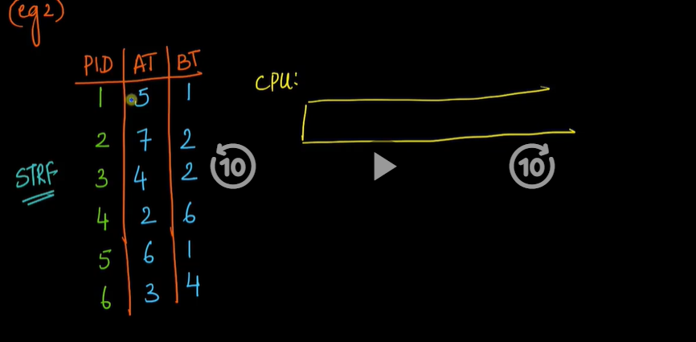

**Here problem in SJF, FCFS and in SRTF is we are assuming that the burst time of processes are already known , but in real time we can’t calculate the burst time of the process priorily**

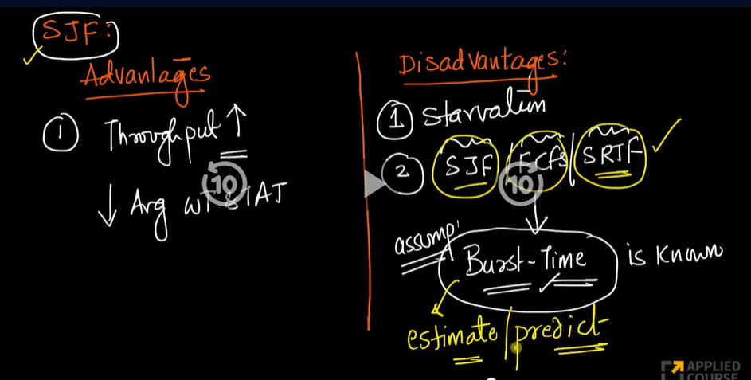

**Predicting Burst Time**

* 1. **Using size of process**
     1. **Not a best predictator**

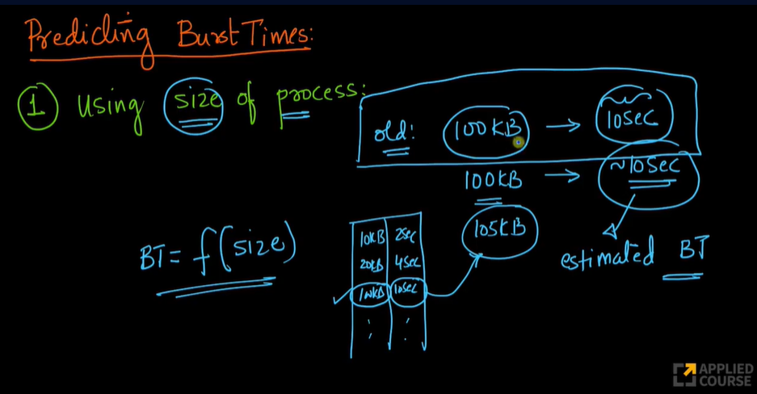

* 1. **Using type of process**
     1. **better strategy to estimate burst time**

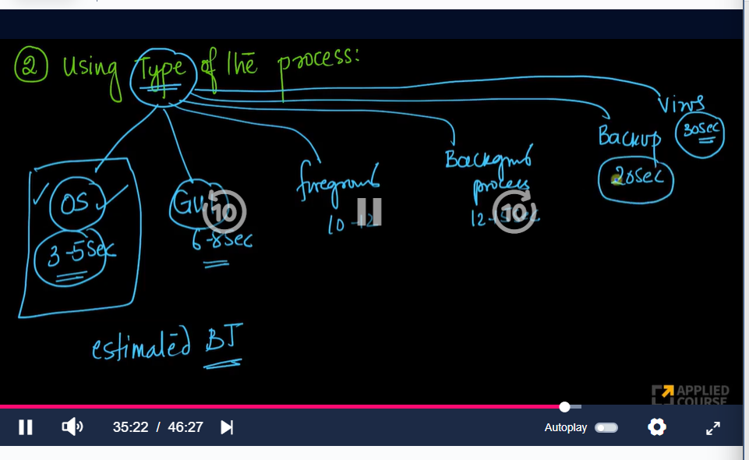

* 1. **averaging previous CPU Burst**

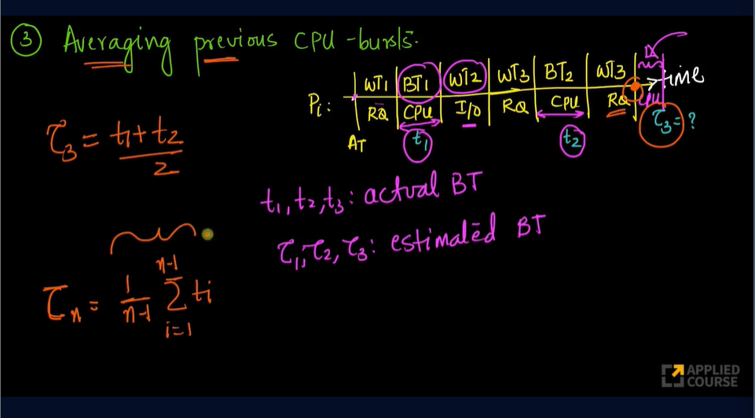

* 1. **Exponential averaging / Ageing algo**

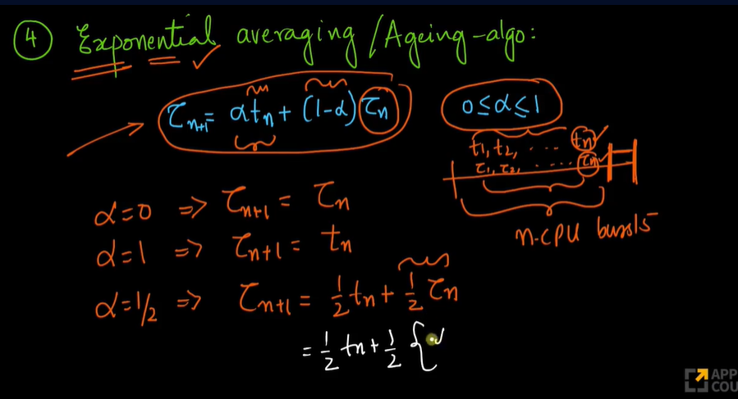

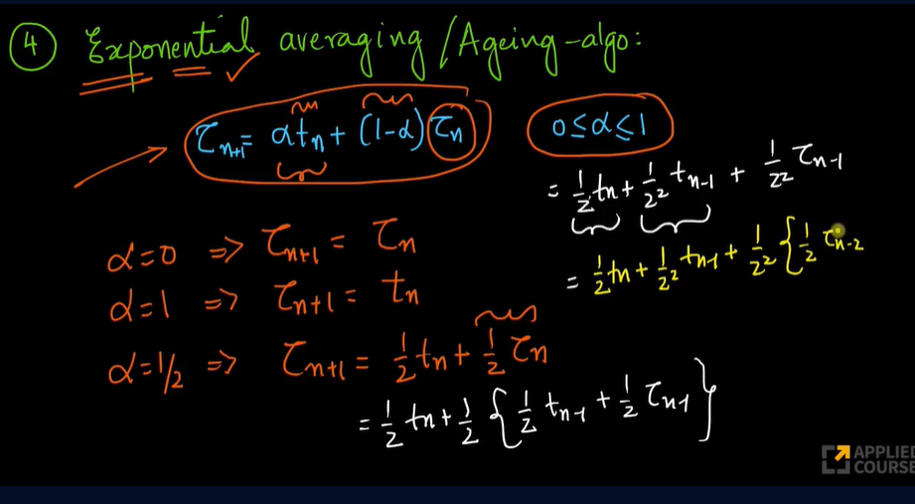

1. **Longest remaining time first (LRTF)**
   1. Preemptive
   2. Criteria: maximum burst time
   3. Starvation reduced
   4. Context switching increased

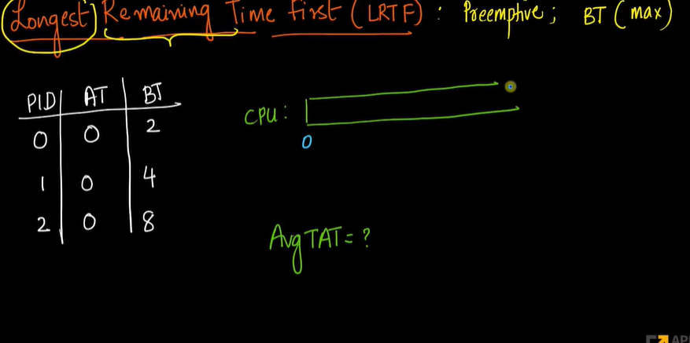

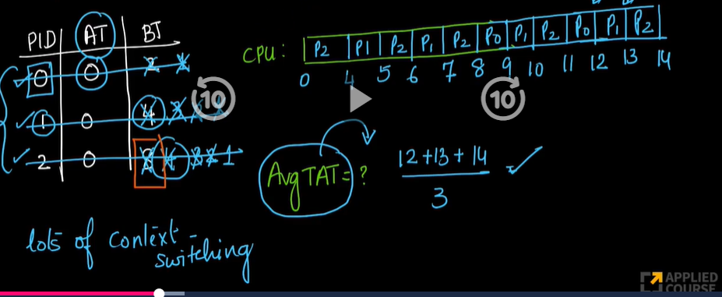

1. **Highest response ratio next(HRRN)**
   1. Response ratio:

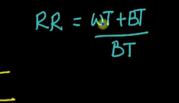

* 1. Non – preemptive
  2. Criteria : Highest response ratio process will took first
  3. Starvation reduces

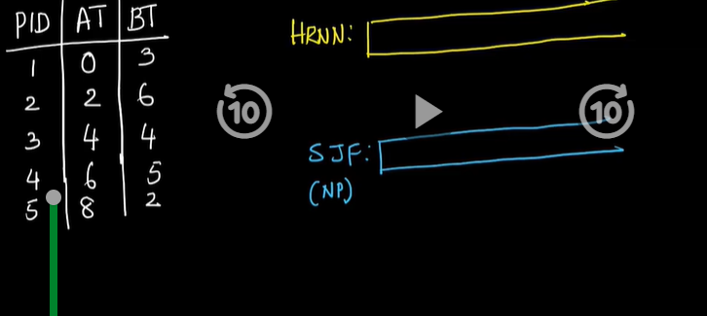

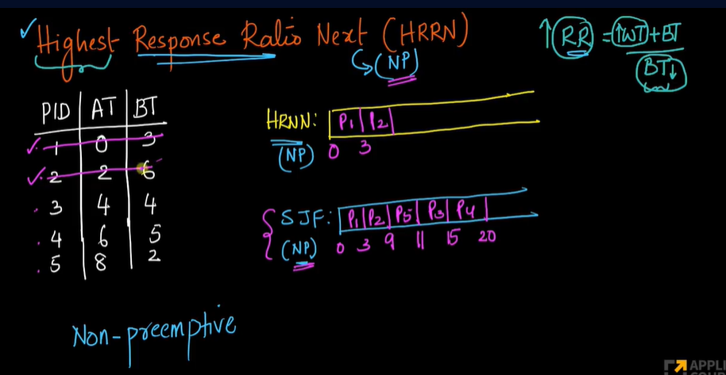

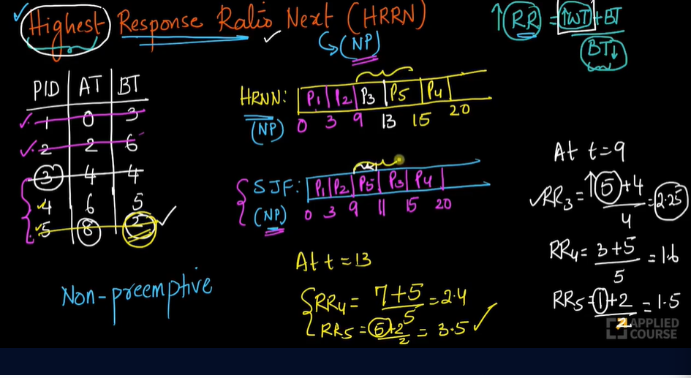

1. **Priority Bases Scheduling**
   1. Linux or android use this algo
   2. Preemptive or non-preemptive
   3. Criteria: Priority score
   4. Priority score can be static or dynamic

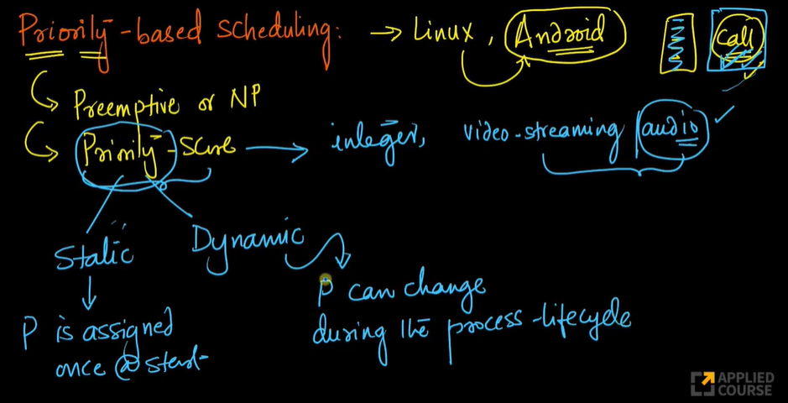

* 1. df